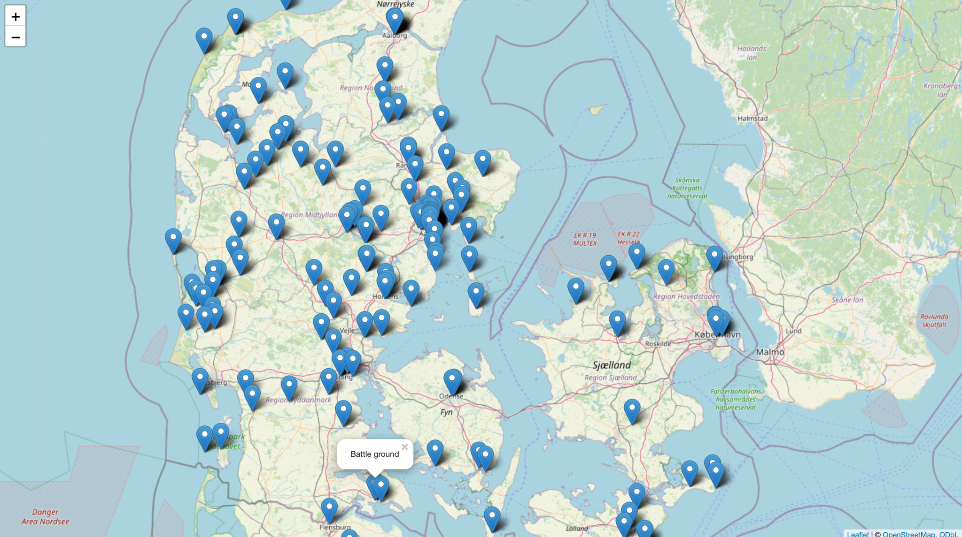

Visualisation:

Question: What patterns can be observed in the spatial distribution of leisure places in Denmark?

Explanation/Answer: The map shows that leisure places are mainly concentrated in urban areas such as Aarhus and Copenhagen, while fewer locations appear in rural areas.
The clustering function groups nearby points, improving the readability of areas with high density. This highlights how leisure activities are unevenly distributed across Denmark and demonstrates how geospatial visualization can be used to identify spatial patterns.

GitHub repository: https://github.com/Digital-Methods-HASS/AUID_Bountovski_Vladimir

